Part E – Effect of Predictor Coefficient Using MATLAB

For a = 0, 0.5, 0.8, 1, 1.2

After calculating MSE for each coefficient, we got these values:
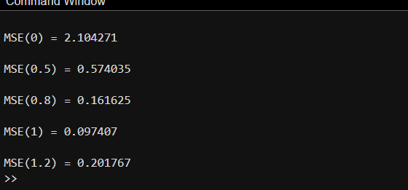

And here is what the plot looks like:
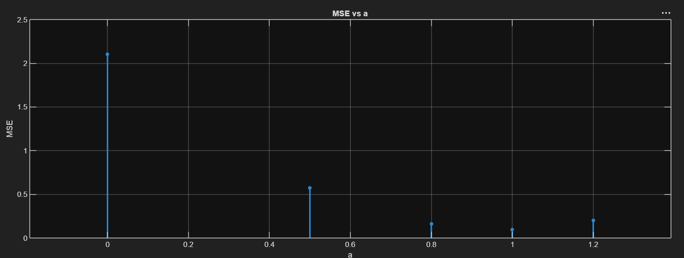

Questions (8 - 11):

- Which value gives the minimum MSE?
We get the minimum MSE when a = 1.

- Is a = 1 necessarily the optimum predictor?
No, a =1 is the best coefficient out of the values given, but we could calculate an even better coefficient (optimum predictor coeff.) to give us the least MSE possible.

- What determines the optimum predictor coefficient?
It’s determined by minimizing the prediction MSE. The value of a that produces the smallest MSE is considered the optimum coefficient.

- What happens when the predictor coefficient is poorly selected?
When the predictor coefficient is poorly selected, the predicted signal is less similar to the original signal. This increases the prediction error e[n], which increases the MSE, resulting in a poorer prediction.

